RACE/ETHNICITY GRAPHS AND HYPOTHESIS

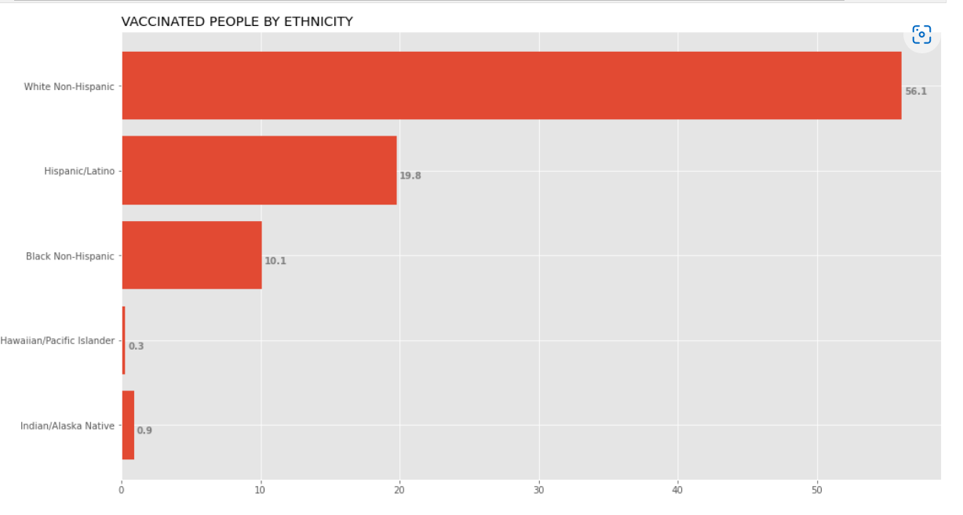

Hypothesis: VACCINATED PEOPLE BY RACE/ETHNICITY.

We can see approximately 97875147 vaccinated people are White (~56.1%).

97875147 vaccinated people are White (~56.1%).

34579296 vaccinated people are Hispanic (~19.8%).

17689531 vaccinated people are Black (~10.1%).

569662 vaccinated people are Hawaiian (~0.3%).

1498047 vaccinated people are American Indian (~0.9%).

For a total of approximately 5 Races/Ethnicities represented.

The population breakdown of vaccinated people by race. According to the Center for Disease Control and Prevention, the US population % of White (Non-Hispanic) is (59.4%), Black or African American (Non-Hispanic) is (12.4%), Hispanic/Latino is (19.2%), American Indian (Non-Hispanic) is (0.7%), and Hawaiian (Non-Hispanic) is (0.3%).

In conclusion, according to this dataset:

White vaccinated people are LESS than the US white population.

Hispanic vaccinated people are MORE than the US Hispanic population.

Black vaccinated people are LESS than the US black population.

Hawaiian vaccinated people are EQUAL to the US Hawaiian population.

American Indian vaccinated people are MORE than the US American Indian population.

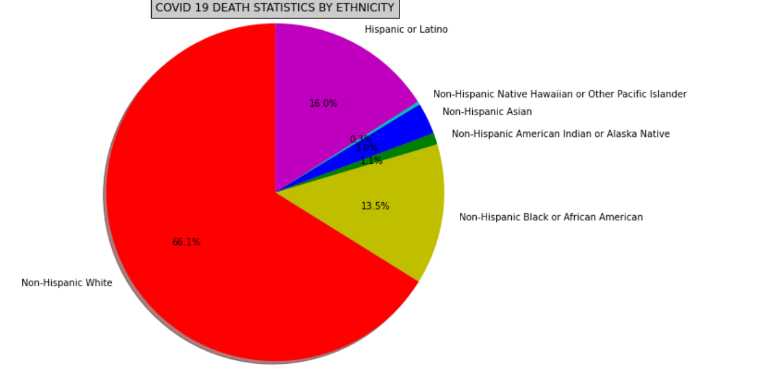

Hypothesis: COVID 19 DEATH STATISTICS BY ETHNICITY.

Approximately 304824 dead people are White.

304824 dead people are White (~66.1%).

73478 dead people are Hispanic (~16.0%).

62036 dead people are Black (~13.5%).

1182 dead people are Hawaiian (~0.3%).

5056 dead people are American Indian (~1.1%).

13787 dead people are Asian (~3.0%).

For a total of approximately 6 Races/Ethnicities represented.

The population breakdown of COVID 19 deaths by race. According to the Center for Disease Control and Prevention, the COVID 19 deaths percentage for White (Non-Hispanic) is (~66.1%), Hispanic is (~16.0%) Black (Non-Hispanic) is (~13.5%), Hawaiian (Non-Hispanic) is (~0.3%), American Indian (Non-Hispanic) is (~1.1%), and Asian (Non-Hispanic) is (~3.0%).

In conclusion, the COVID 19 death rate for white people has surpassed the rates for Black, Hispanic/Latino, Hawaiian, Asian, and Americans Indian.